1. **List all employees who are managers of department 10.**

**Solution**

select * from emp

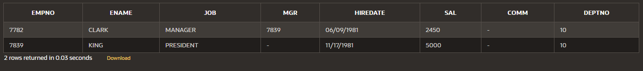where deptno=10

1. **List all employees who do NOT work in department number 10, 20.**

**Solution**

select * from emp

where deptno not in(10,20)

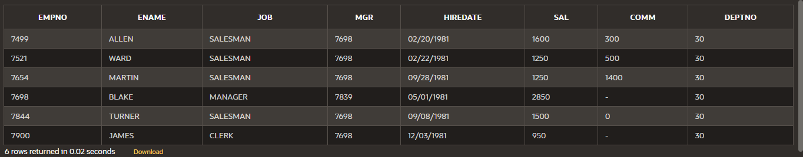

1. **List all employees having first letter in their name 'W' OR 'K’ and they do NOT belong to department number 10 OR 20.**

**Solution**

select * from emp

where (ename like 'W%' OR ename like 'K%') and (deptno not in (10,20))

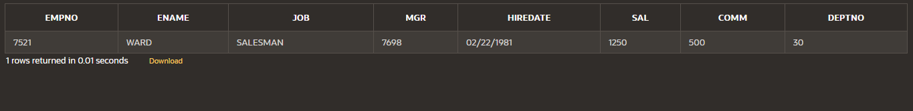

1. **List those employees whose name’s third last letter is ‘I’**

**Solution**

select* from emp

where ename like '%I__'

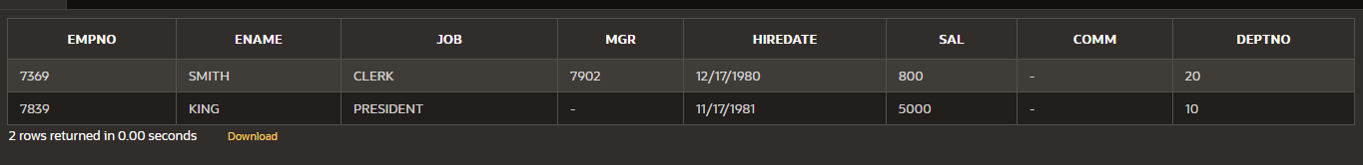

1. **List those employees having first letter in their name 'F’ and the name contains exactly 4 letters**

**.Solution**

select * from emp

where ename like 'F%' and length(ename)= 4



1. **List those employees whose names starts with ‘S’ and end with ‘H’**

**Solution**

select * from emp

where ename like 'S%H'

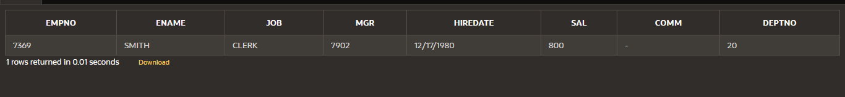

1. **Find those employees whose MGR IS 7902, 7566, 7788.**

**Solution**

select * from emp

where mgr in(7902,7566,7788)

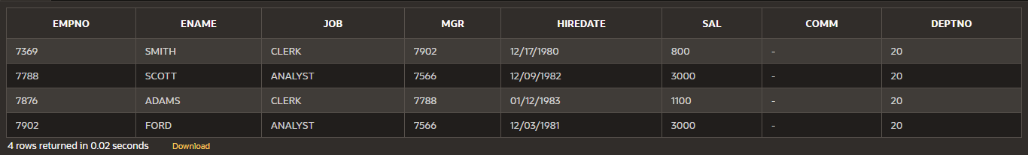

1. **List all employees who are NOT manager.**

**Solution**

select * from emp

where job <> 'MANAGER'

|  |  |  |  |  |  |  |  |
| --- | --- | --- | --- | --- | --- | --- | --- |
| **EMPNO** | **ENAME** | **JOB** | **MGR** | **HIREDATE** | **SAL** | **COMM** | **DEPTNO** |
| 7369 | SMITH | CLERK | 7902 | 12/17/1980 | 800 | - | 20 |
| 7499 | ALLEN | SALESMAN | 7698 | 02/20/1981 | 1600 | 300 | 30 |
| 7521 | WARD | SALESMAN | 7698 | 02/22/1981 | 1250 | 500 | 30 |
| 7654 | MARTIN | SALESMAN | 7698 | 09/28/1981 | 1250 | 1400 | 30 |
| 7788 | SCOTT | ANALYST | 7566 | 12/09/1982 | 3000 | - | 20 |
| 7839 | KING | PRESIDENT | - | 11/17/1981 | 5000 | - | 10 |
| 7844 | TURNER | SALESMAN | 7698 | 09/08/1981 | 1500 | 0 | 30 |
| 7876 | ADAMS | CLERK | 7788 | 01/12/1983 | 1100 | - | 20 |
| 7900 | JAMES | CLERK | 7698 | 12/03/1981 | 950 | - | 30 |
| 7902 | FORD | ANALYST | 7566 | 12/03/1981 | 3000 | - | 20 |

1. **List all employees who are NOT PRESIDENT, ANALYST OR SALESMAN**

**Solution**

select * from emp

where job not in('PRESIDENT','ANALYST','SALESMAN')

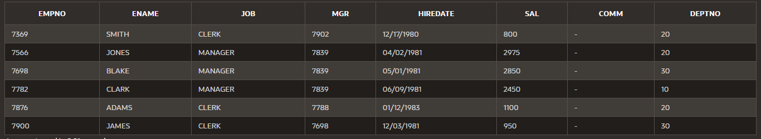

1. **List all employees with the name that have "LL" in any position**

**Solution**

select * from emp

where ename like '%LL%'



1. **Find those employees whose salary is 1600,2975,2850**

**Solution**

select * from emp

where sal in (1600,2975,2850)

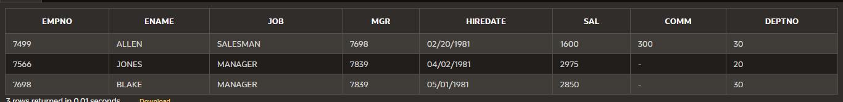

1. **List those employees having salary between 1000 and 3000 and with no commission**

**Solution**

select * from emp

where comm is null and (sal between 1000 and 3000)

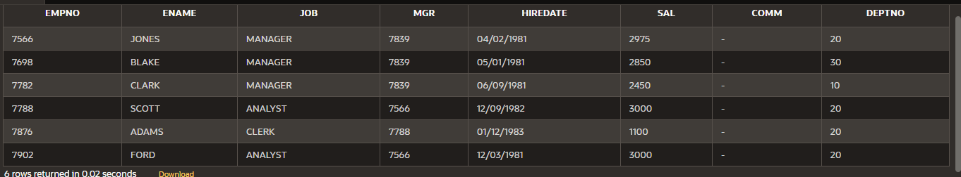

1. **List those employees having salary between 1000 and 2000 and their manager is 7788**

**Solution**

select * from emp

where (sal between 1000 and 3000) and mgr =7788

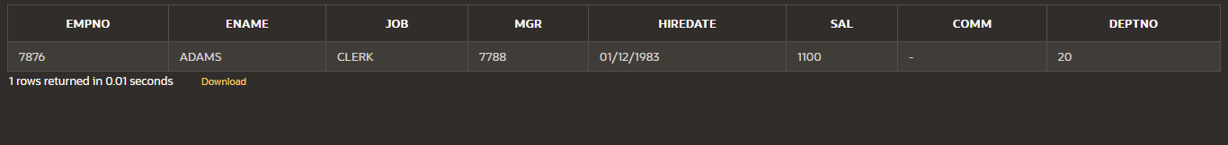

1. **List those employees where job is CLERK and deptno is 10 OR 30**

**Solution**

select * from emp

where job ='CLERK' and deptno in(10,30)



1. **Find the annual salary of the employees and sort it in descending order**

**Solution**

select ename,sal*12 as Annual_Salary from emp

order by Annual_Salary desc

|  |  |
| --- | --- |
| **ENAME** | **ANNUAL_SALARY** |
| KING | 60000 |
| SCOTT | 36000 |
| FORD | 36000 |
| JONES | 35700 |
| BLAKE | 34200 |
| CLARK | 29400 |
| ALLEN | 19200 |
| TURNER | 18000 |
| WARD | 15000 |
| MARTIN | 15000 |
| ADAMS | 13200 |
| JAMES | 11400 |
| SMITH | 9600 |

1. **List all the employees sorted descending by the job and ascending by the salary**

**Solution**

select ename,sal*12 as Annual_Salary from emp

order by job desc, sal asc

|  |  |
| --- | --- |
| **ENAME** | **ANNUAL_SALARY** |
| WARD | 15000 |
| MARTIN | 15000 |
| TURNER | 18000 |
| ALLEN | 19200 |
| KING | 60000 |
| CLARK | 29400 |
| BLAKE | 34200 |
| JONES | 35700 |
| SMITH | 9600 |
| JAMES | 11400 |
| ADAMS | 13200 |
| FORD | 36000 |
| SCOTT | 36000 |

1. **List all distinct jobs from the emp table**

**Solution**

select distinct job from emp

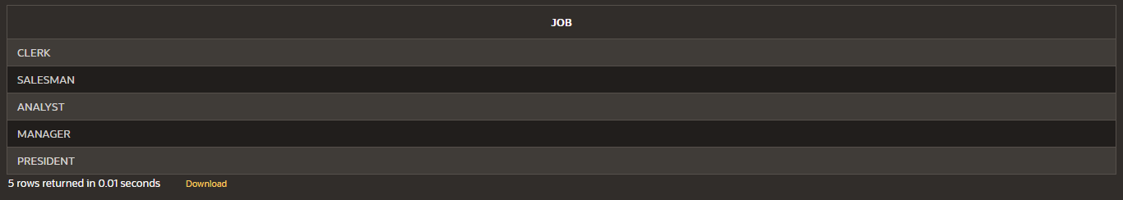

1. **List the employees who have no manager**

**Solution**

select * from emp

where mgr is null

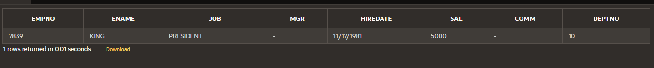

1. **List the distinct managers**

**Solution**

select distinct mgr from emp

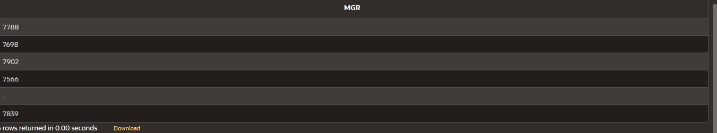

1. **List all employees by sorting the hiredate in ascending order**

**Solution**

select * from emp

order by hiredate asc

|  |  |  |  |  |  |  |  |
| --- | --- | --- | --- | --- | --- | --- | --- |
| **EMPNO** | **ENAME** | **JOB** | **MGR** | **HIREDATE** | **SAL** | **COMM** | **DEPTNO** |
| 7369 | SMITH | CLERK | 7902 | 12/17/1980 | 800 | - | 20 |
| 7499 | ALLEN | SALESMAN | 7698 | 02/20/1981 | 1600 | 300 | 30 |
| 7521 | WARD | SALESMAN | 7698 | 02/22/1981 | 1250 | 500 | 30 |
| 7566 | JONES | MANAGER | 7839 | 04/02/1981 | 2975 | - | 20 |
| 7698 | BLAKE | MANAGER | 7839 | 05/01/1981 | 2850 | - | 30 |
| 7782 | CLARK | MANAGER | 7839 | 06/09/1981 | 2450 | - | 10 |
| 7844 | TURNER | SALESMAN | 7698 | 09/08/1981 | 1500 | 0 | 30 |
| 7654 | MARTIN | SALESMAN | 7698 | 09/28/1981 | 1250 | 1400 | 30 |
| 7839 | KING | PRESIDENT | - | 11/17/1981 | 5000 | - | 10 |
| 7902 | FORD | ANALYST | 7566 | 12/03/1981 | 3000 | - | 20 |
| 7900 | JAMES | CLERK | 7698 | 12/03/1981 | 950 | - | 30 |
| 7788 | SCOTT | ANALYST | 7566 | 12/09/1982 | 3000 | - | 20 |
| 7876 | ADAMS | CLERK | 7788 | 01/12/1983 | 1100 | - | 20 |